**ICON**

Enhancements to DDAS Web Application

**Brief Business Requirements**

Rev 1

13 Nov, 2017

**And Implementation Status**

5 Dec, 2017

Prepared by:

**Clarity Information Technologies Pvt. Ltd.**

Tel: +91-080-2529 1698, 4115 5410

Email: mail@claritytechnologies.com

# Application Versions:

The following implementations versions were uploaded on the test server

1. **T1.0.19 - 24 Nov 2017**
2. **T1.0.20 – 5 Dec 2017**
3. **T1.0.21 – 5 Dec 2017**

**The version number is marked against each item in the section ‘Proposed Solution’ in dark blue.**

# Requirements

The existing DDAS Web application needs to be enhanced with the following additions.

1. Input Template Enhancement
   1. Capability of the tool to be modified to include 2 study numbers as the Due Diligence checks are requested for investigators who would be participating in 2 studies at once.
   2. Input template as well as tool should accept 2 study numbers at once so 1 compliance search form should be generated for investigators with 2 studies in it.
2. QC Work Flow
   1. Arrangement to allow the junior resource to pass on their works to senior resource for review along with any comments and similarly, senior resource allowed to review as well as pass this back on junior resource with any review comments
3. Admin Dashboard
   1. A new dashboard to be incorporated into tool for all Admins.
   2. Include the admin related results in table formats
   3. Include the graphical representation or any presentable form for management purpose.
4. Advanced Reports
   1. A detailed report on all investigators based on the findings status (after review) for a Specified Period / Resource / Studies
   2. Report listing investigators with No Findings
   3. Report listing investigators with Findings.
   4. Reassignment report to understand how many investigators were reassigned for Specified Period / Resource
   5. Study Specific report with all investigators completed along with the Date of Review Completed, Findings status with Resource Names
   6. A report with details of all investigators completed for a specific period of time along with time taken for each review for each investigator. This report is to be available for all Users as well.
5. Minor Corrections
   1. Corrections in Search Filters
      1. Currently tool is searching based on the full name of the investigators, but would need the individual filters as First and Last name.
   2. Automated Text inclusion in ICSF
      1. Tool to automatically add text “NA” in final ICSF for Medical License Number field if there were no Medical license provided by User.
   3. Reset keyword in filter
      1. When User uses any keyword on the review page to filter matches, currently tool retains the keyword typed by User earlier even after user moves & comes back to same later. This should be reset by tool so the User doesn’t get confused on the filter search.
   4. Bright Highlights
      1. The provided highlights on the matches are mild and User facing difficulties viewing on screen. The highlight needs to be improved further to make it more bright or dark to improve this.
   5. Increased Page Size
      1. Currently, tool provides the matches in quite smaller page which leads User to scroll down quite lot or more to different page to find all matches. So this page layout or page needs to be increased to incorporate larger no. of matches to help user review more stress-free.

1. Download facility for Data Files downloaded from Search Sites.

# Proposed Solution

## Input Template Enhancement

* 1. The Investigator Compliance Search Form will include an additional field ‘ICON Project Number’ as shown below: **(Version 1.10.19)**

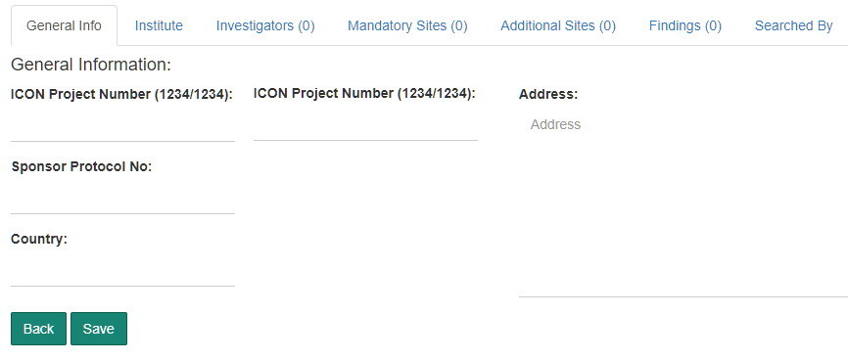

* 1. Input template as well as the tool will accept one or two study numbers and the same will be displayed in the fields shown above. **(Version 1.10.19)**
  2. The generated Compliance Form will display both ICON Project Numbers wherever two ICON Project Numbers are available. **(Version 1.10.21)**

## QC Work Flow

1. The ‘Search Resource’ (auditee) will be able to assign a Compliance Form for audit and identify an Auditor. **(Version 1.10.19)**
2. The application will send an email alert informing the Auditor to take up the Audit. **(Version 1.10.21)**
3. The Auditor can login and open the Compliance Form for Audit **(Version 1.10.19)**
4. The Auditor will not be permitted to modify the contents of the Compliance Form created by the Auditee. **(Version 1.10.19)**
5. The following fields will be provided for the Auditor to provide observations.
   * 1. Comments
     2. Accepted / Rejected

These fields will be available at Compliance Form level and against each finding. **(Version 1.10.19)**

1. The Auditor will mark the Audit as completed and an email alert will inform the Auditee about the status. **(Version 1.10.21)**

## Admin Dashboard

1. A dashboard with current status will be available for the Admin. **(Version 1.10.19)**

|  |  |  |  |  |
| --- | --- | --- | --- | --- |
| **User** | **Opening Balance** | **Compliance forms uploaded** | **Compliance forms completed** | **Closing Balance** |
| David | 5 | 9 | 7 | 7 |
| Naveen | 2 | 6 | 3 | 5 |
| Maya | 3 | 7 | 8 | 2 |

1. Include the graphical representation or any presentable form for management purpose. **(Pending)**

## Advanced Reports

1. A detailed report on all investigators based on the findings status (after review) for a Specified Period / Resource / Studies
2. Filters
   * + 1. Review Completed On – From and To **(Pending)**
       2. Resource Name **(Pending)**
       3. Study Number **(Pending)**
       4. Finding Status (No Findings, Findings) **(Version 1.10.19)**
3. Columns
4. Name of the Investigator
5. Study Number
6. Review Completed On
7. Findings Status (Issues Identified / Issues Not Identified)
8. Investigated by (Resource Name)

**(Version 1.10.19)**

1. Reassignment report to understand how many investigators were reassigned for Specified Period / Resource
2. The application workflow will be arranged to record Date and Time of Assignment of the Compliance form to a Resource. **(Version 1.10.19)**
3. When the Compliance Form is uploaded the Resource is automatically assigned to the uploaded Compliance Form **(Version 1.10.19)**
4. The Date and Time when the Compliance form is taken out from the current Resource will be recorded. **(Version 1.10.19)**
5. A report will be generated with the following columns.
6. Project Number
7. Principal Investigator
8. Resource
9. Resource Assigned on – Date and Time
10. Resource Removed on – Date and Time

|  |  |  |  |  |
| --- | --- | --- | --- | --- |
| Project Number | Principal Investigator | Resource | Assigned on | Assignment Removed On |
| 1234/5678 | David Jones | Ram | 1-Jan-2017, 2:30 PM | 5-Jan-2017, 7:00 AM |
| 1234/5678 | David Jones | Shyam | 5-Jan-2017, 7:00 AM |  |

**(Version 1.10.19)**

1. Study Specific report with all investigators completed along with the Date of Review Completed, Findings status with Resource Names

Study Number[ 1111/2222 ]

|  |  |  |  |
| --- | --- | --- | --- |
| Investigator Name | Date Review Completed | Findings Status | Resource Name |
| David Jones | 5-Sep-2017 | Issues Identified | Ram |
| William Joseph | 12-Oct-2017 | Issues Not identified | Shyam |

**(Version 1.10.19)**

1. A report with details of all investigators completed for a specific period of time along with time taken for each review for each investigator. This report is to be available for all Users as well.

Review completed during [ from date ] and [ to date ]

|  |  |  |  |
| --- | --- | --- | --- |
| Investigator Name | Review Completed On | Status | Time Taken (in minutes) |
|  |  |  |  |
|  |  |  |  |

* + - * Time Taken is the time duration between Date and Time the Compliance Form is uploaded and searched AND the Date and Time when the Investigator Review is completed.
      * The above computation does not take into consideration the actual time used by the Resource to carry out the review of that specified Investigator.
      * A Compliance Form that is carried over to the next day will result in a inaccurate result.

**(Version 1.10.19)**

## Minor Corrections

1. Corrections in Search Filters
2. Currently tool is searching based on the full name of the investigators, but would need the individual filters as First and Last name.

This facility is currently available. The application user can paste any part of the name, First Name or Last Name to get filtered records. **(Already exists)**

1. Automated Text inclusion in ICSF
2. Tool to automatically add text “NA” in final ICSF for Medical License Number field if there were no Medical license provided by User.

This will be provided.

**(Version 1.10.20)**

1. Reset keyword in filter
2. When User uses any keyword on the review page to filter matches, currently tool retains the keyword typed by User earlier even after user moves & comes back to same later. This should be reset by tool so the User doesn’t get confused on the filter search.
3. This will be corrected.

**(Version 1.10.20)**

1. Bright Highlights
2. The provided highlights on the matches are mild and User facing difficulties viewing on screen. The highlight needs to be improved further to make it more bright or dark to improve this.

This will be provided.

**(Version 1.10.21)**

1. Increased Page Size

Currently, tool provides the matches in quite smaller page which leads User to scroll down quite lot or more to different page to find all matches. So this page layout or page needs to be increased to incorporate larger no. of matches to help user review more stress-free.

An option to select the number of items per page (5, 10, 25, 50, 100) will be provided.

**(Version 1.10.20)**

## Download facility for Data Files downloaded from Search Sites.

Archive data files from all Search Sites and make them available for download.

**(Version 1.10.20)**